**INTRODUCTION**

**Introduction**

**Ramkrishna Multipurpose Lawn and Hall :**

The Multipurpose Lawn and Hall Website project aims to develop a website for a versatile venue that can be used for various events such as weddings, corporate gatherings, parties, and conferences. The website serves as a platform for users to explore the facilities, view available dates, make bookings, and inquire about services offered by the venue.

In Modern Generation we all going to switch things online. So why not multipurpose hall book online. In Our website We provide all information about hall like changing room with a/c , dining hall, garden view, and much more things. We can book hall for celebrating weddings, festivals like holi, friendship day party, and corporate functions, bday parties etc.

At Ramkrishna Multipurpose Hall, we pride ourselves on providing a comprehensive range of facilities to meet the diverse needs of our clients. Our hall is designed to accommodate various events, from weddings and receptions to corporate seminars and birthday parties. Here are some of the facilities you can expect:

**1. Spacious Hall:** Our hall boasts ample space, allowing for flexible seating arrangements and accommodating both small and large gatherings comfortably.

**2. Audio-Visual Equipment:** We offer state-of-the-art audio-visual equipment, including sound systems, projectors, screens.

**3. Catering Services:** We collaborate with top-tier catering services to provide delectable menus tailored to your preferences and dietary requirements.

**4. Parking Facilities:** Ample parking space is available on-site for the convenience of your guests, ensuring hassle-free arrivals and departures.

**5. Restrooms:** Clean and well-maintained restroom facilities are provided for the comfort and convenience of your guests.

**6. Decor Options:** We offer customizable décor options to suit your theme and preferences, allowing you to create the perfect ambiance for your event.

**7. Experienced Staff:** Our professional and experienced staff are dedicated to providing personalized service and ensuring that every aspect of your event runs smoothly.

These facilities are just a glimpse of what Ramkrishna Multipurpose Hall has to offer. We are committed to exceeding your expectations and making your event truly memorable.

**System Analysis :**

**System Analysis :**

System Analysis by definition is a process of systematic investigation for the purpose of gathering data, interpreting the facts, diagnosing the problem and using this information to either build a completely new system or to recommend the improvement to the existing system.

**Ramkrishna Multipurpose lawn and Hall :**

The Ramkrishna Multipurpose Lawn and Hall website is a digital platform designed to assist individuals and event organizers in arranging various gatherings, such as weddings, parties, conferences, and seminars. With its user-friendly interface and comprehensive features, the website aims to provide easy access to information about the venue's facilities, event schedules, and booking procedures.

The system analysis for the Ramkrishna Multipurpose Lawn and Hall website involves identifying target audience, key features, and technical requirements. It includes sections for home, about, services, gallery, booking, and contact. The website will be developed using HTML/CSS/JavaScript.

**SITE MAP**

**SITE MAP**

**Web-Development Stages**

**Website Design 7 steps:**

1. Goal identification: Where I work with the client to determine what goals the new website needs to fulfill. I.e., what its purpose is.
2. Scope definition: Once we know the site's goals, we can define the scope of the project. I.e., what web pages and features the site requires to fulfill the goal, and the timeline for building those out.
3. Sitemap and wireframe creation: With the scope well-defined, we can start digging into the sitemap, defining how the content and features we defined in scope definition will interrelate.
4. Content creation: Now that we have a bigger picture of the site in mind, we can start creating content for the individual pages, always keeping search engine optimization (SEO) in mind to help keep pages focused on a single topic. It's vital that you have real content to work with for our next stage:
5. Visual elements: With the site architecture and some content in place, we can start working on the visual brand. Depending on the client, this may already be well-defined, but you might also be defining the visual style from the ground up.
6. Testing: By now, you've got all your pages and defined how they display to the site visitor, so it's time to make sure it all works.
7. Launch: Once everything's working beautifully, it's time to plan and execute your site launch! This should include planning both launch timing and communication strategies — i.e., when will you launch and how will you let the world know? After that, it's time to break out the bubbly.

**TECHNOLOGY - USED**

**TECHNOLOGY USED**

**Technologies used:**

1. HTML (Hypertext Markup Language):

• Description: HTML is the standard markup language used for creating the structure and content of web pages.

• Key Features: Defines the basic structure of a web page using elements like headings, paragraphs, images, links, etc.

1. CSS (Cascading Style Sheets):

• Description: CSS is a style sheet language used for describing the presentation of a document written in HTML.

• Key Features: Controls the layout, formatting, and appearance of web pages, allowing for customization and responsive design.

1. JavaScript (JS) :

• Description: JavaScript is a lightweight, interpreted programming language primarily used to create dynamic and interactive content on web pages.

• Key Features: JavaScript allows for the manipulation of HTML and CSS, enabling dynamic updates to web pages without requiring a reload. This facilitates the creation of interactive user interfaces

**SYSTEM REQUIREMENTS**

**Hardware and Software Requirement:**

1. **Hardware Requirements:**

The Computer with following configuration requirement to implement the system.

* **3 GB RAM**
* **Intel Core i3 Processor**
* **Hard Disk 1TB or SSD upto 250GB**

1. **Software Requirements:**

* **Operating System- Windows 10 and above**
* **Visual Studio 2008**
* **MS-Access**

**OUTPUT SCREENS**

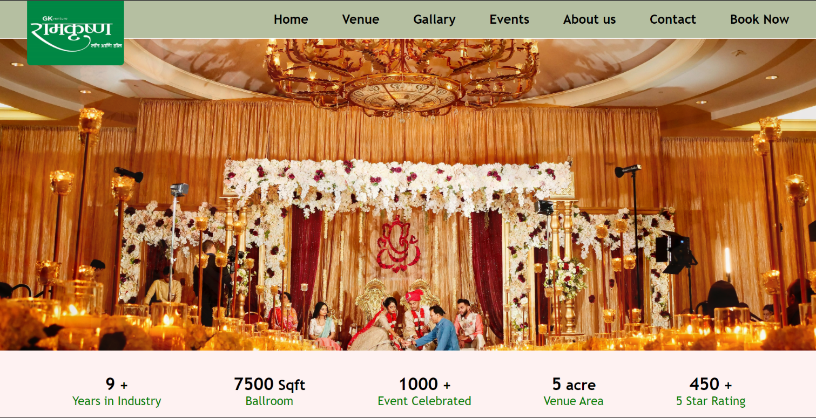**Home :**

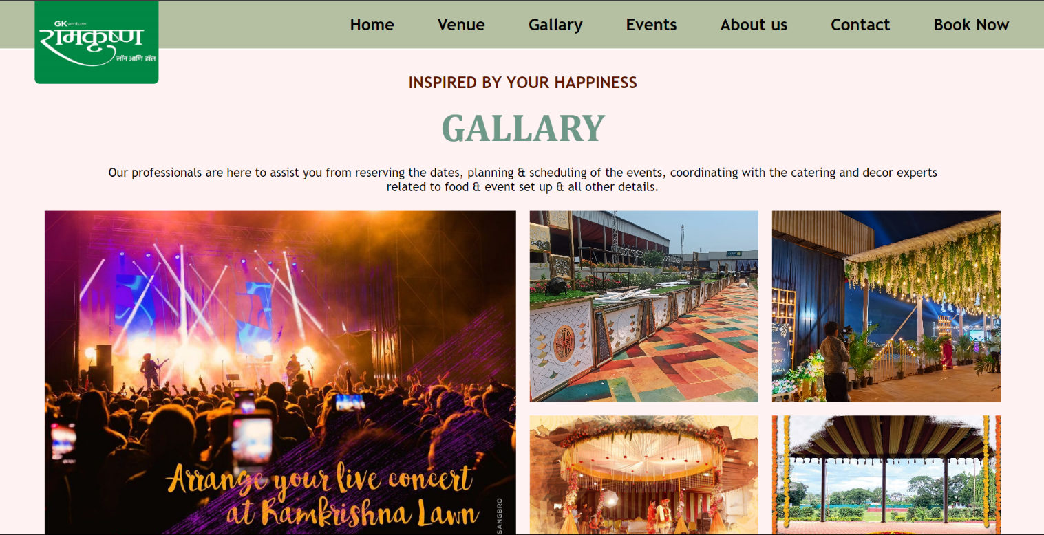

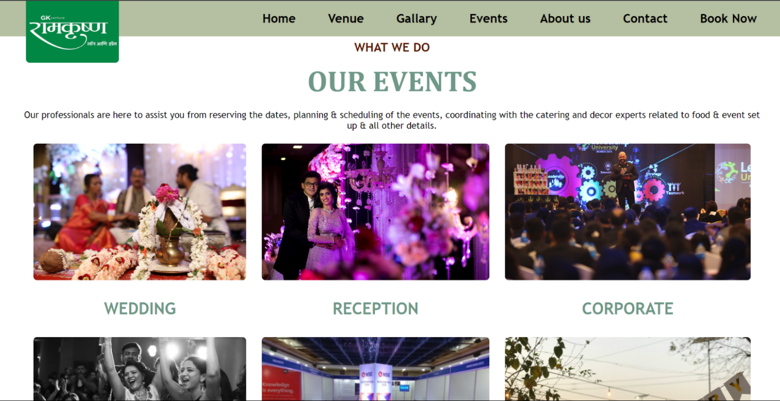

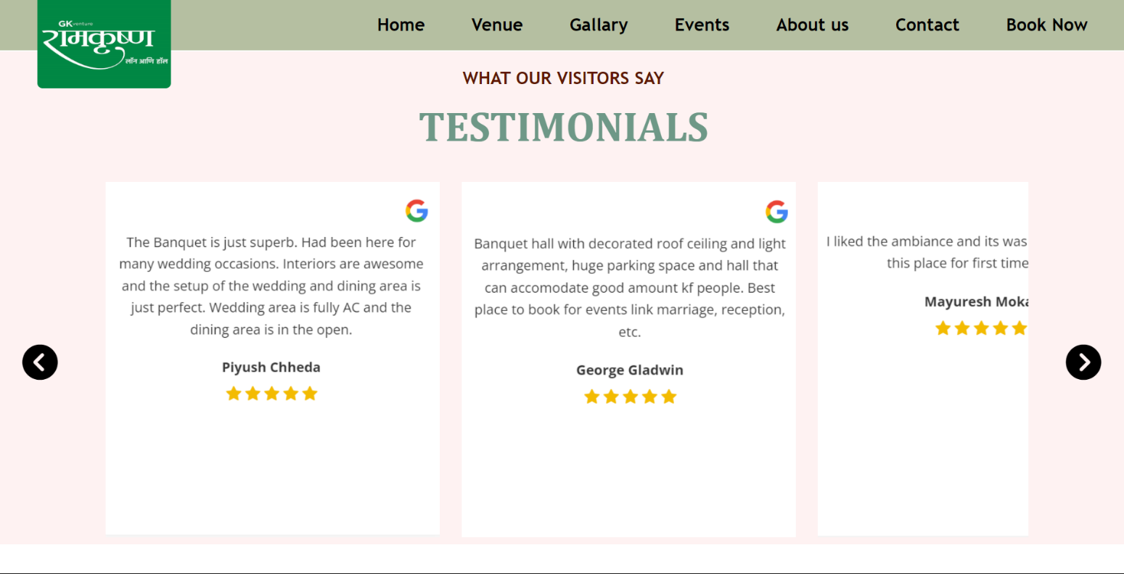 **Review :**

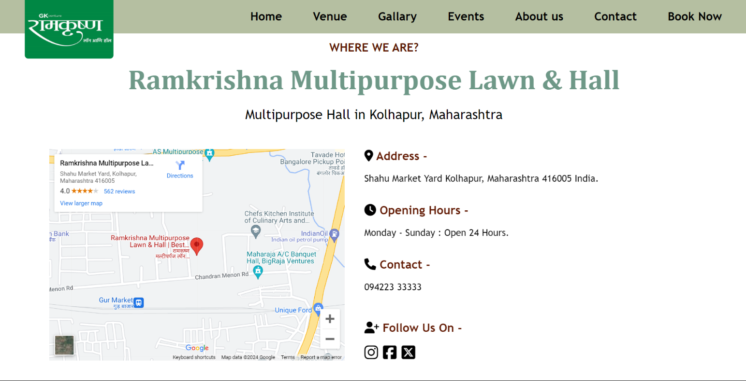**Footer :**

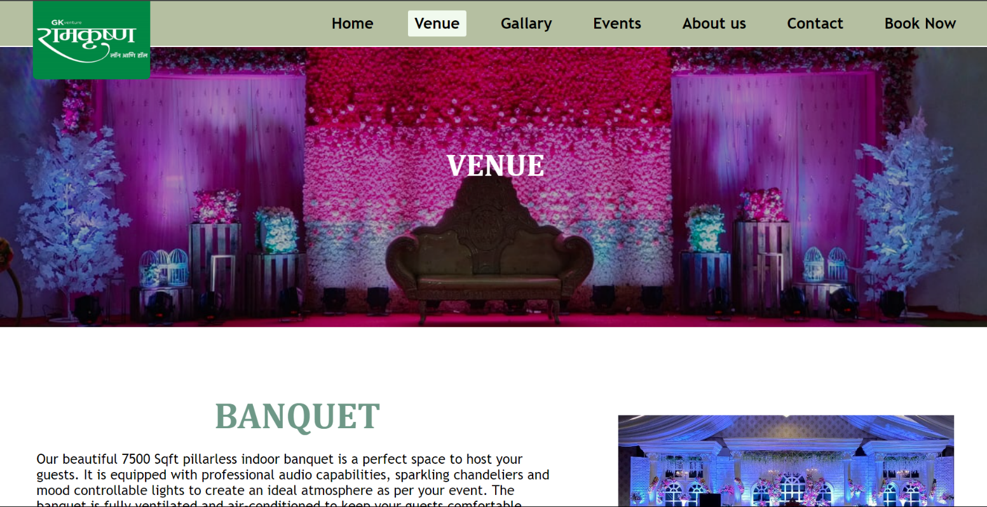**Venue :**

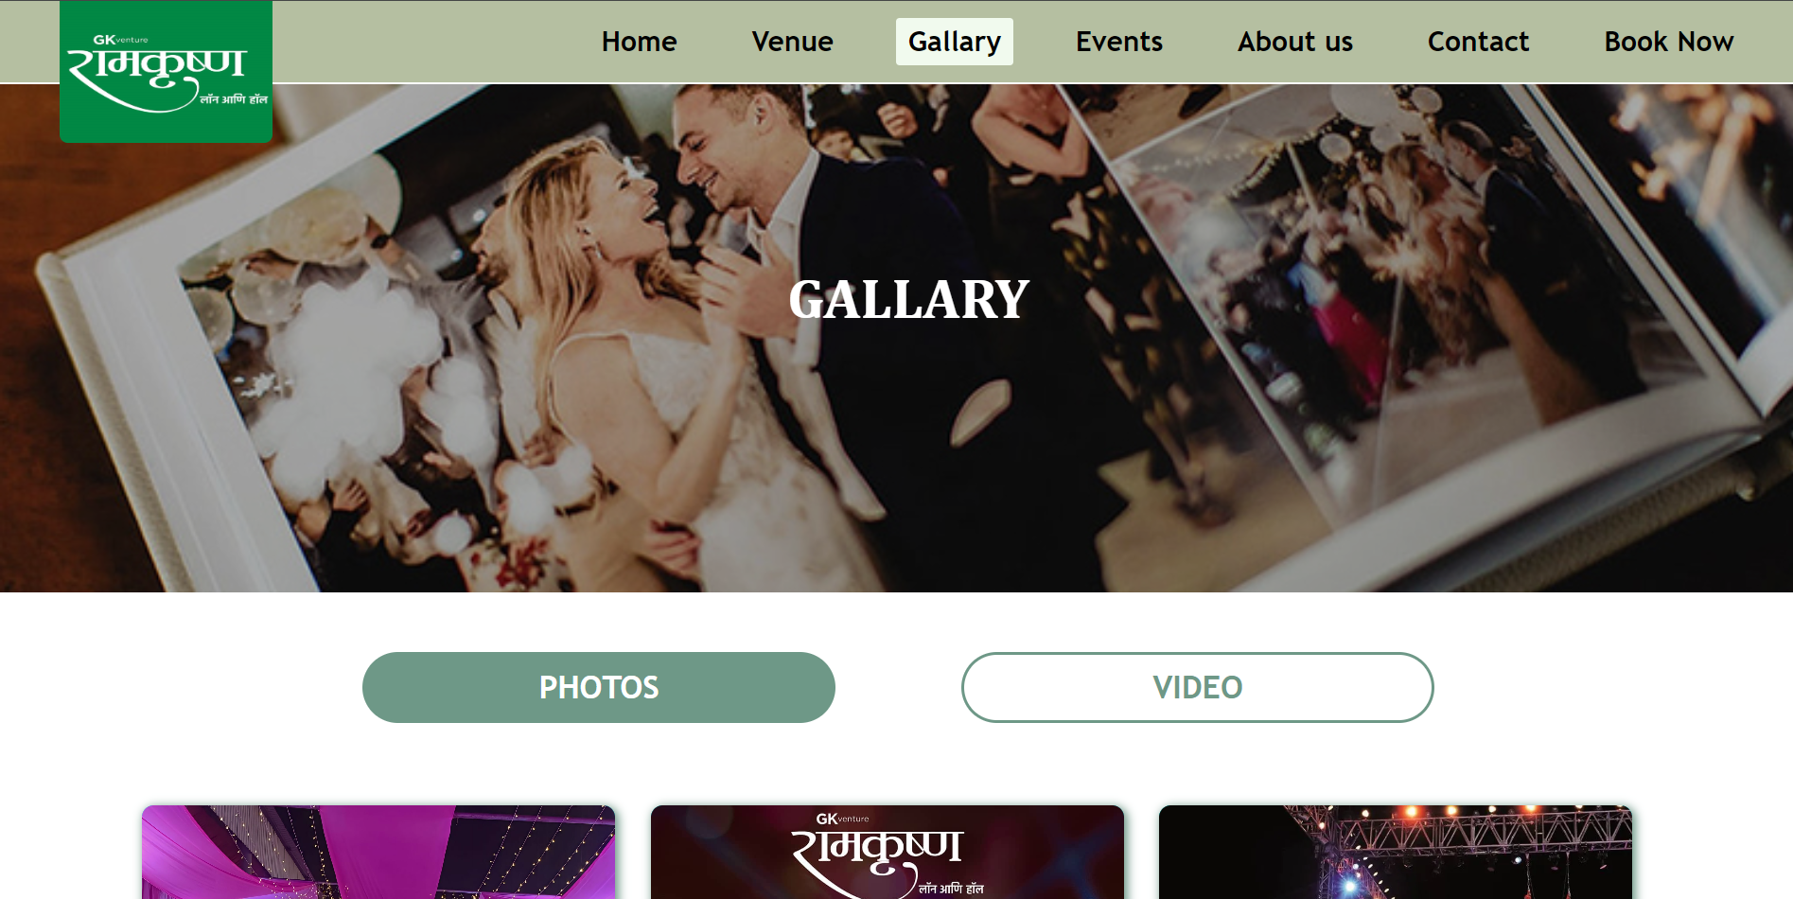**Gallary :**

**Events :**

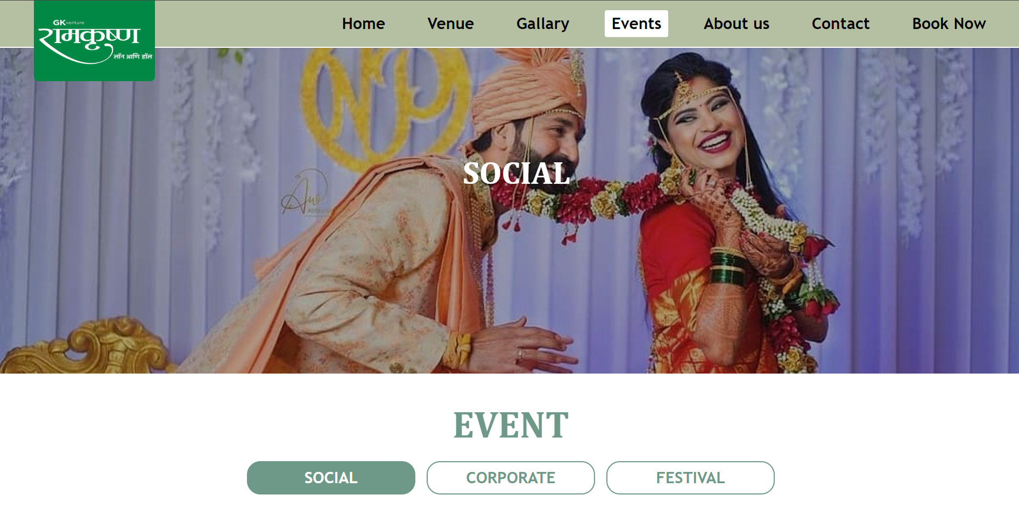

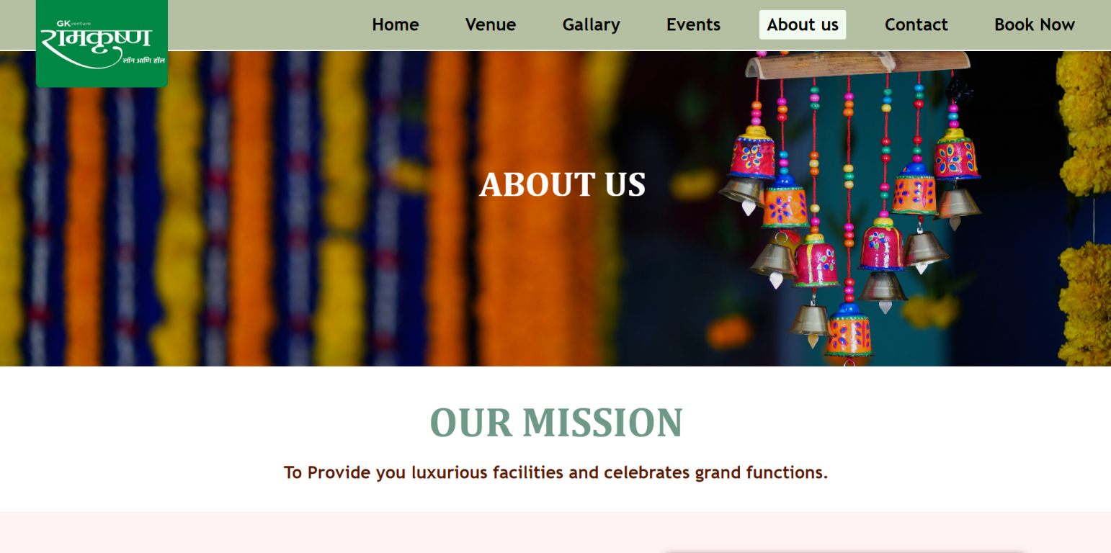**About us :**

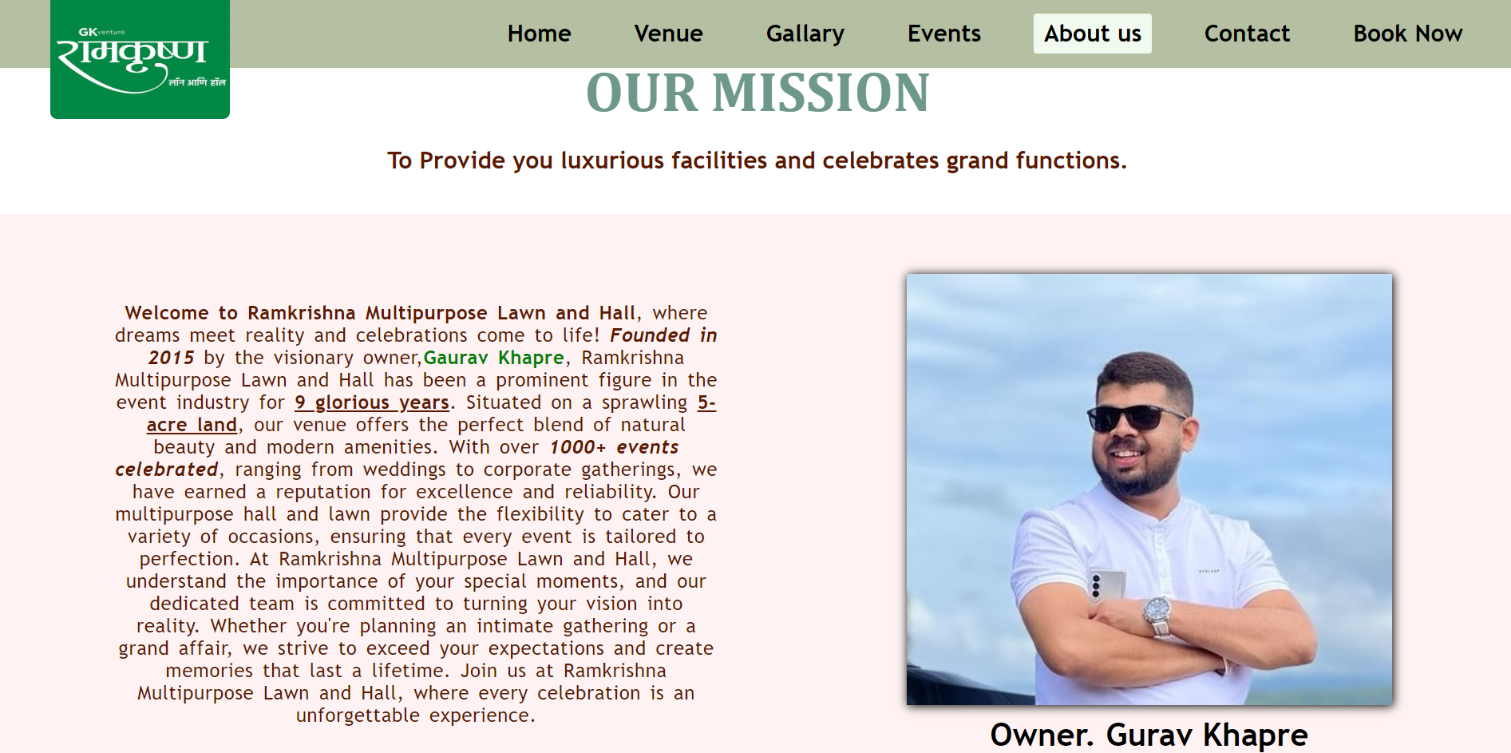

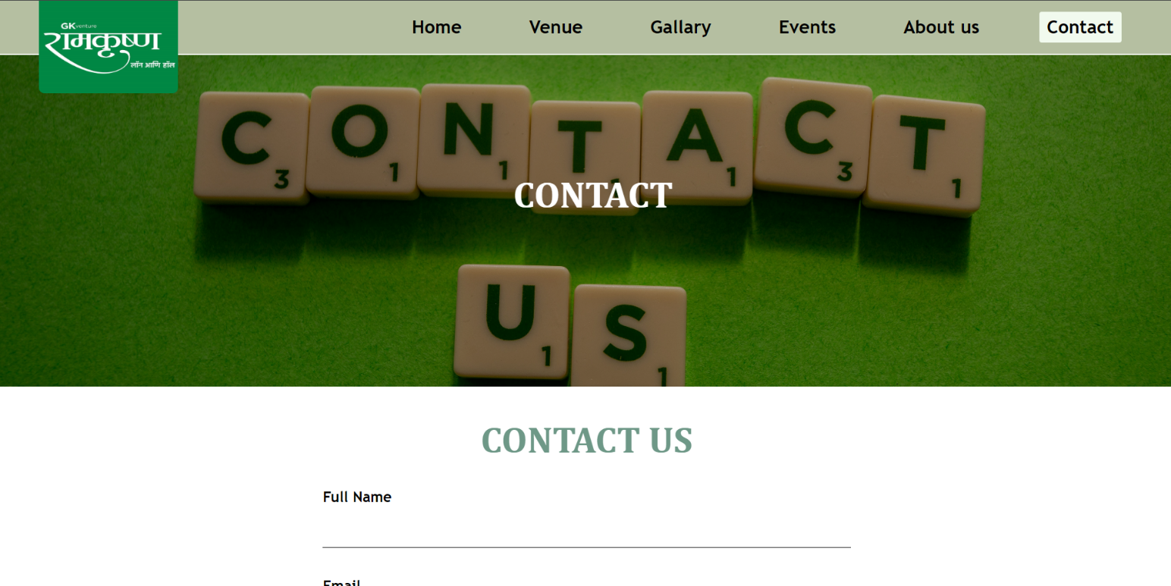**Contact Us :**

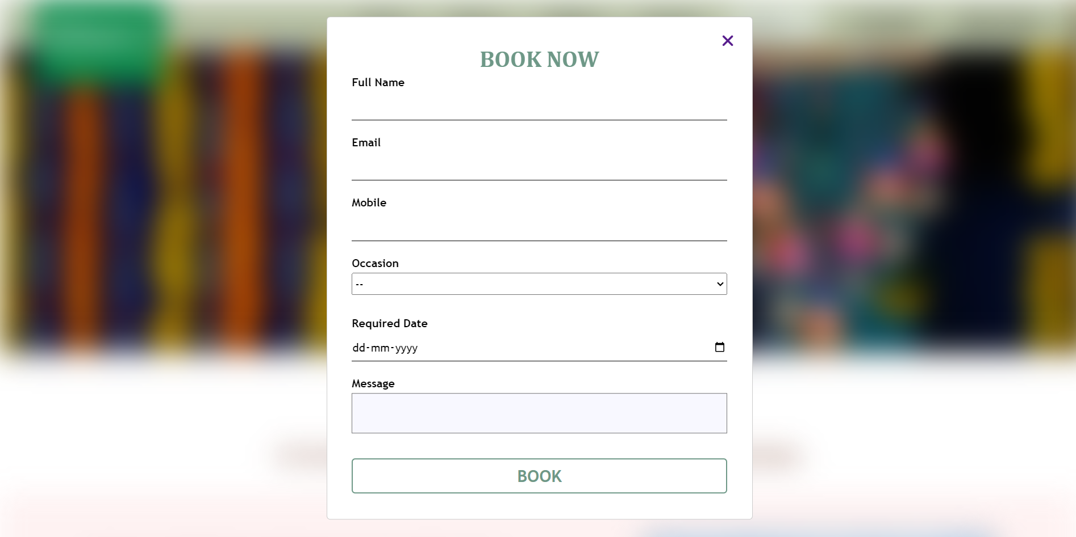**Book Now :**

**CONCLUSION**

**CONCLUSION :**

wrapped up our project to create the website for Ramkrishna Multipurpose Lawn and Hall. It's been quite a journey, but we're thrilled with the end result.

Our website is like a digital brochure for the venue, showcasing its beauty and all the services it offers. We've made sure it's easy to navigate and looks great.

By creating this website, we're helping Ramkrishna Multipurpose Lawn and Hall reach more people and attract potential customers. We've worked hard to make sure the website is user-friendly and captures the essence of the venue.

In the process of developing the website, we have adhered to the highest standards of professionalism, incorporating feedback and suggestions from stakeholders to refine and enhance the final product. Our commitment to excellence and dedication to meeting client expectations have been integral to the successful completion of this project.

Thanks to everyone who contributed to this project. We're excited to see how the website helps Ramkrishna Multipurpose Lawn and Hall grow and thrive in the future.

**Limitation :**

* This website is static not a dynamic website.

**REFERENCES**

**References :**

1 . Websites :

* + - [https://www.google.com](https://www.google.com    )
    - [www.youtube.com](http://www.youtube.com)
    - <https://unplash.com>

2. Books :

* HTML & CSS Quickstart
  + - * David DuRocher
* Web Technologies
  + - * Black Book
* HTML. CSS & JAVASCRIPT
  + - * SAMS - person